HW1 A

clear all

clc

function [y]=lagrange(x,x0,y0)

#x0,y0:已知數據點

n=size(x0',1);

y=0;

for j=1:n

Lj=1;

Ljx0=1;

for i=1:n

if i==j #避免除以零的情況

continue

endif

Lj.*= (x-x0(i))/(x0(j)-x0(i));

Ljx0.*= (x0-x0(i))/(x0(j)-x0(i));

endfor

figure(j)

plot(x,Lj,x0,Ljx0,"b+")

xlabel("x");

ylabel("Lj(x)");

legend("Lj(x)","(x0,Lj(x0))");

title(["L",dec2base(j, 10),"(x)"]);

print ("-djpg",["A_L",dec2base(j, 10),".jpg"]);

Lj*=y0(j);

y+=Lj;

endfor

endfunction

xi=[-1:0.2:1];

yi=[0.0385,0.0588,0.1000,0.2000,0.5000,1.0000,0.5000,0.2000,0.1000,0.0588,0.0385];

x=[-1:0.01:1];

y=lagrange(x,xi,yi);

figure(12)

plot(x,y,xi,yi,"b+")

xlabel("x");

ylabel("f(x)");

legend("f(x)","(x0,y0)");

title("Lagrange polynomial");

print("-djpg","A_Lagrange polynomial");

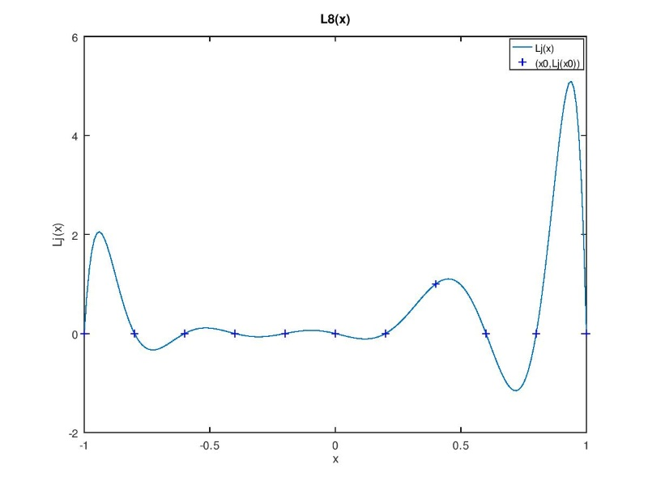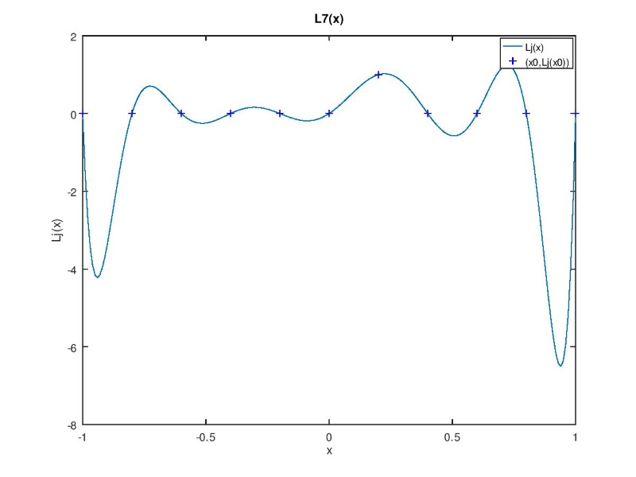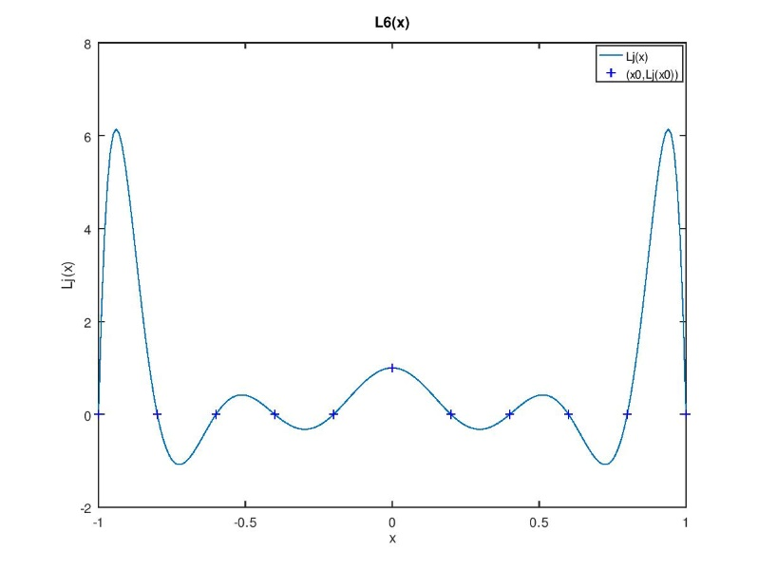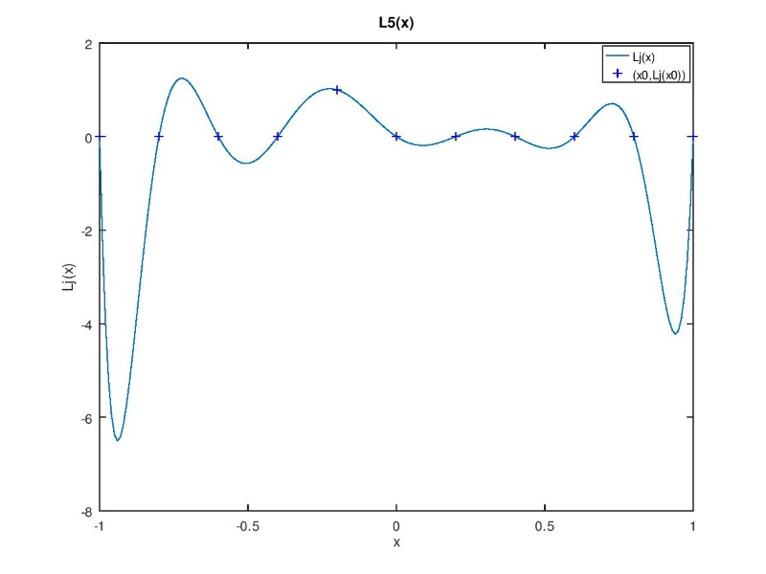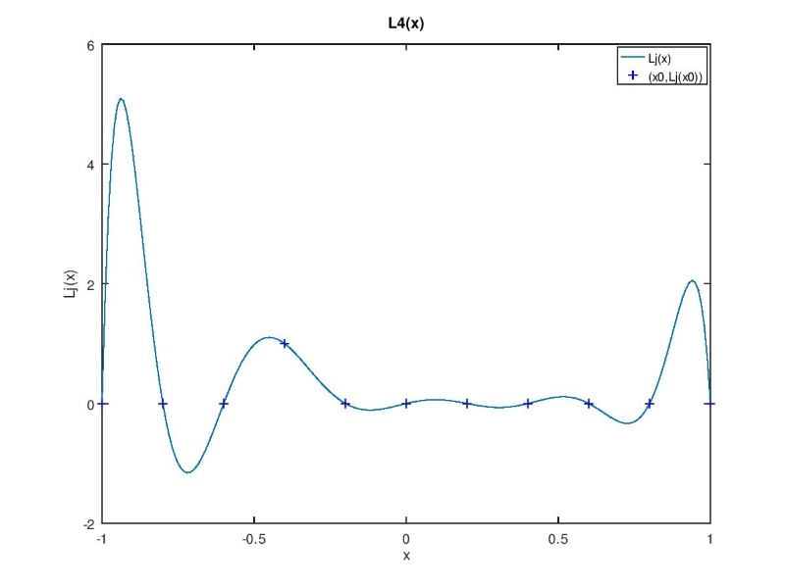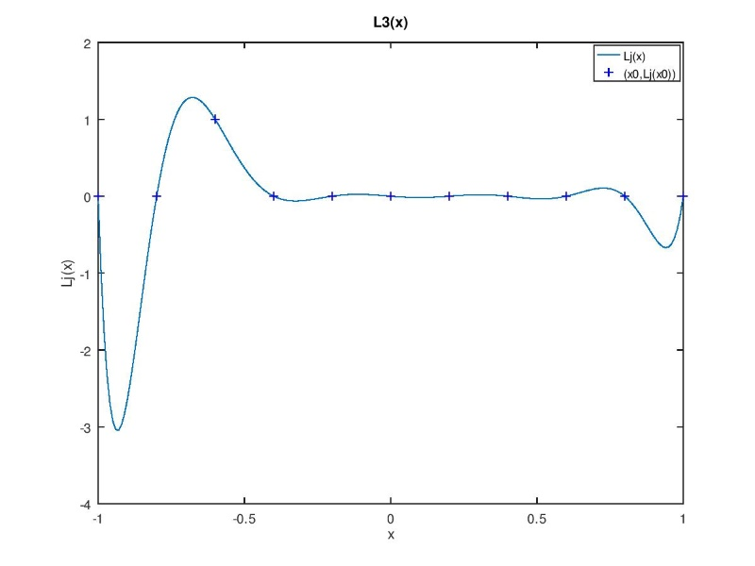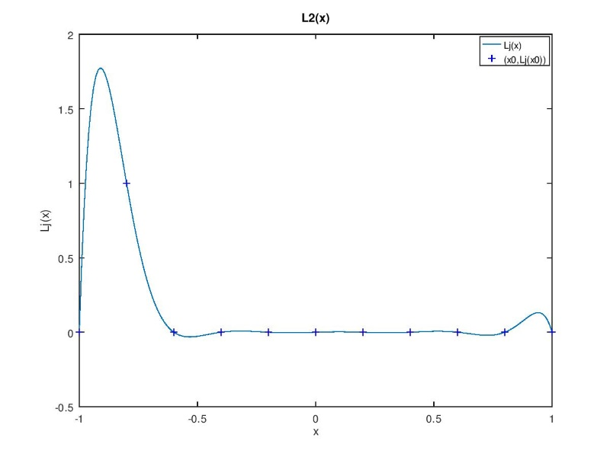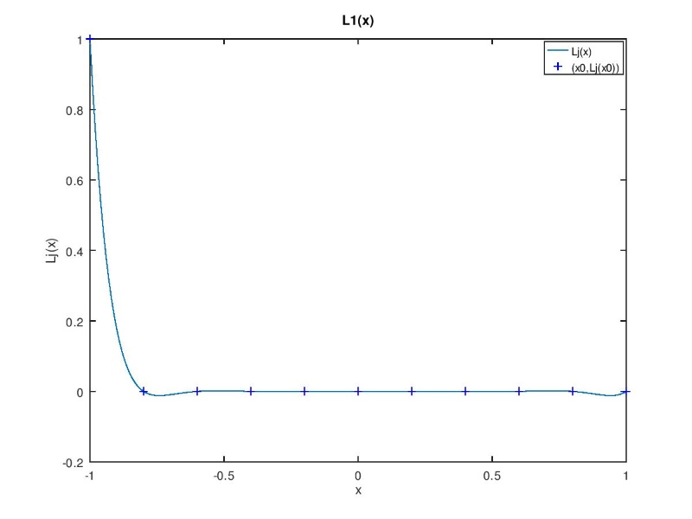

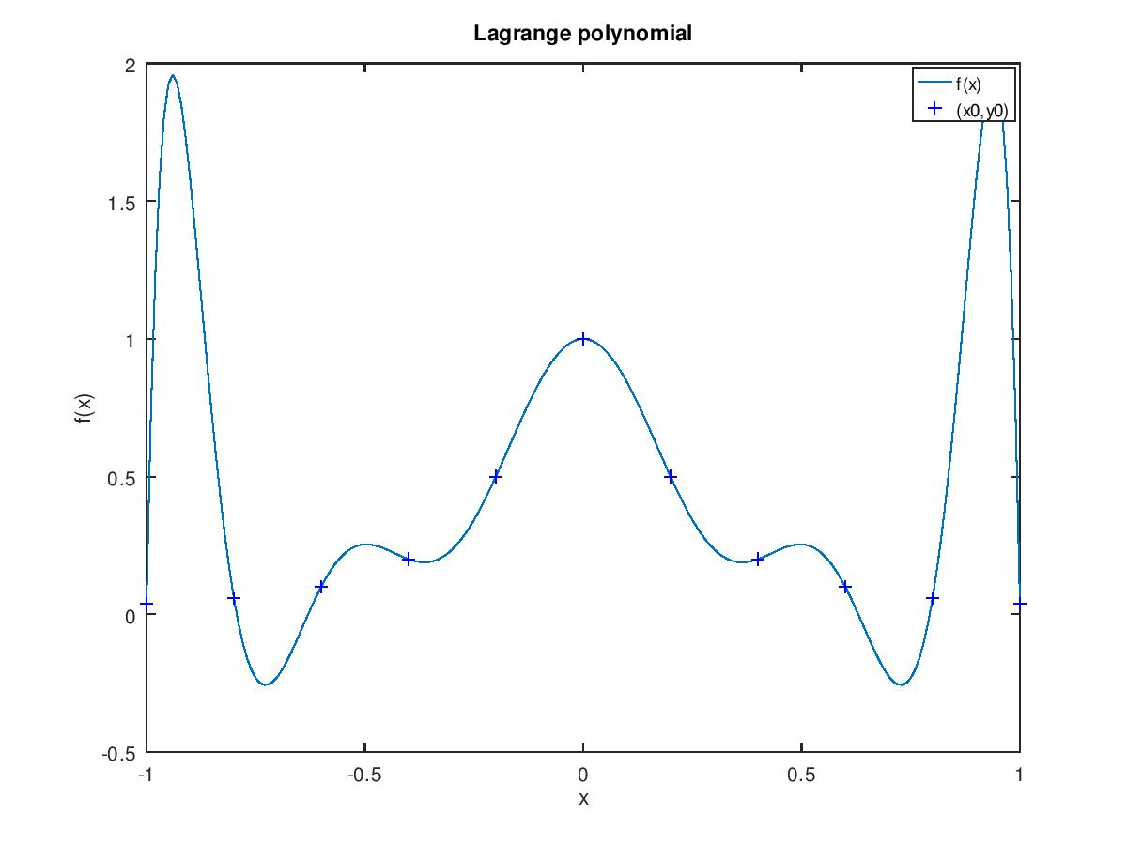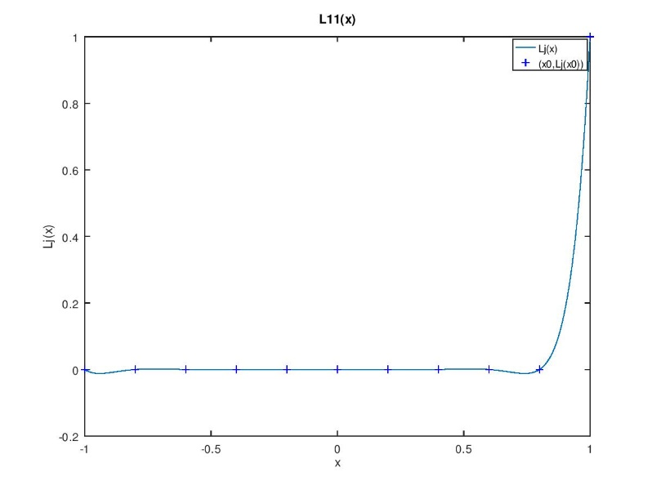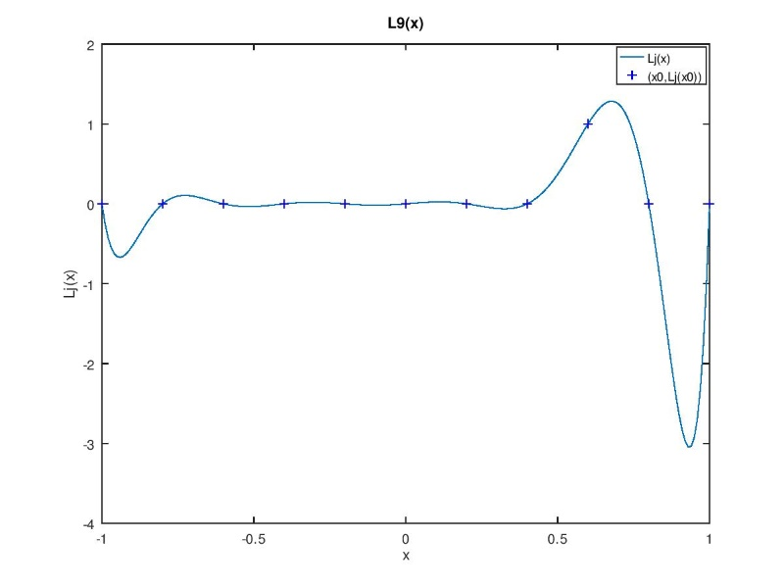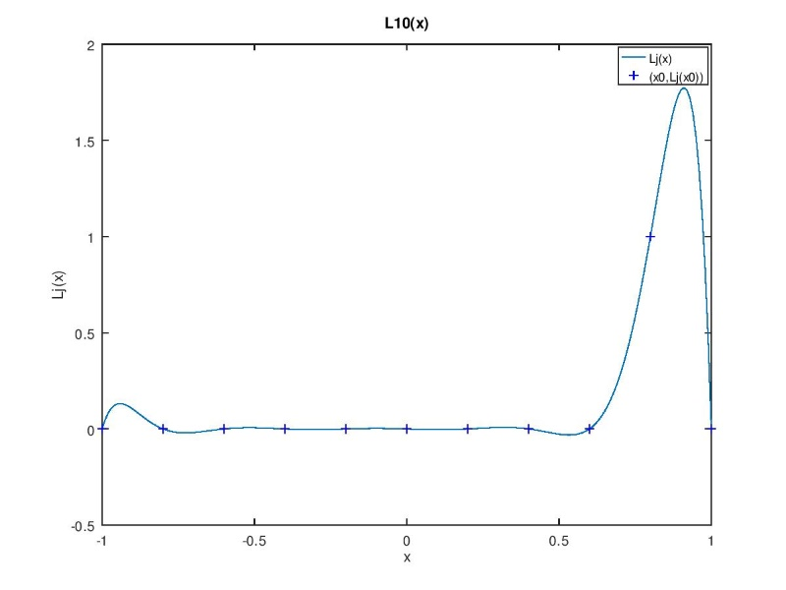

HW1_B

clear all

clc

xi=[-1.0000,-0.8000,-0.6000,-0.4000,-0.2000,-0.0000,0.2000,0.4000,0.6000,0.8000,1.0000];

yi=[0.0385,0.0588,0.1000,0.2000,0.5000,1.0000,0.5000,0.2000,0.1000,0.0588,0.0385];

n=size(xi',1);

A=zeros(n,n);

R=zeros(n,1); #A*sov=R

for i=1:n

if (i==1 | i==n)

A(i,i)=1;

R(i)=0;

continue

endif

A(i,i-1)=(xi(i)-xi(i-1))/6;

A(i,i)=(xi(i+1)-xi(i-1))/3;

A(i,i+1)=(xi(i+1)-xi(i))/6;

R(i)=(yi(i+1)-yi(i))/(xi(i+1)-xi(i))-(yi(i)-yi(i-1))/(xi(i)-xi(i-1));

endfor

sov=A\R #second order value

figure(1)

x=[];

y=[];

for i=1:n-1

x_now=xi(i):0.01:xi(i+1);

di=xi(i+1)-xi(i);

y_now=sov(i)/6 *((xi(i+1)-x_now).^3/di-di*(xi(i+1)-x_now))...

+ sov(i+1)/6 *((x_now-xi(i)).^3/di-di*(x_now-xi(i)))...

+ yi(i)*(xi(i+1)-x_now)/di + yi(i+1)*(x_now-xi(i))/di;

x=[x,x_now];

y=[y,y_now];

endfor

plot(x,y,xi,yi,"b+")

xlabel("x");

ylabel("f(x)");

legend("f(x)","(x0,y0)");

title("cubic spline");

print("-djpg","B_cubic spline");

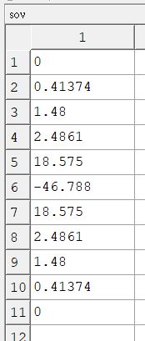

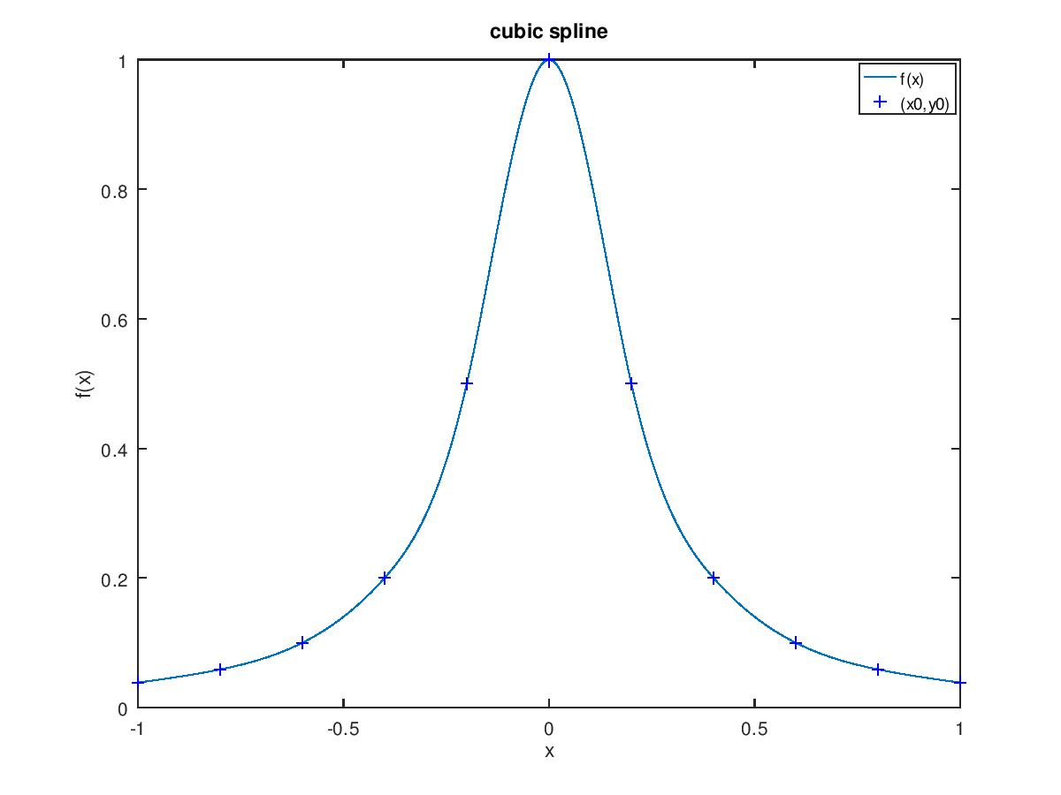

HW1_C

clear all

clc

function [y]=lagrange(x,x0,y0)

#x0,y0:已知數據點

n=size(x0',1);

y=0;

for j=1:n

Lj=1;

Ljx0=1;

for i=1:n

if i==j #避免除以零的情況

continue

endif

Lj.*= (x-x0(i))/(x0(j)-x0(i));

Ljx0.*= (x0-x0(i))/(x0(j)-x0(i));

endfor

figure(j)

plot(x,Lj,x0,Ljx0,"b+")

xlabel("x");

ylabel("Lj(x)");

legend("Lj(x)","(x0,Lj(x0))");

title(["L",dec2base(j, 10),"(x)"]);

print ("-djpg",["C_L",dec2base(j, 10),".jpg"]);

Lj*=y0(j);

y+=Lj;

endfor

endfunction

xi=[-1.0000,-0.9511,-0.8090,-0.5878,-0.3090,0.0000,0.3090,0.5878,0.8090,0.9511,1.0000];

yi=[0.0385,0.0424,0.0576,0.1038,0.2952,1.0000,0.2952,0.1038,0.0576,0.0424,0.0385];

x=[-1:0.01:1];

y=lagrange(x,xi,yi);

figure(12)

plot(x,y,xi,yi,"b+")

xlabel("x");

ylabel("f(x)");

legend("f(x)","(x0,y0)");

title("Lagrange polynomial");

print("-djpg","C_Lagrange polynomial");

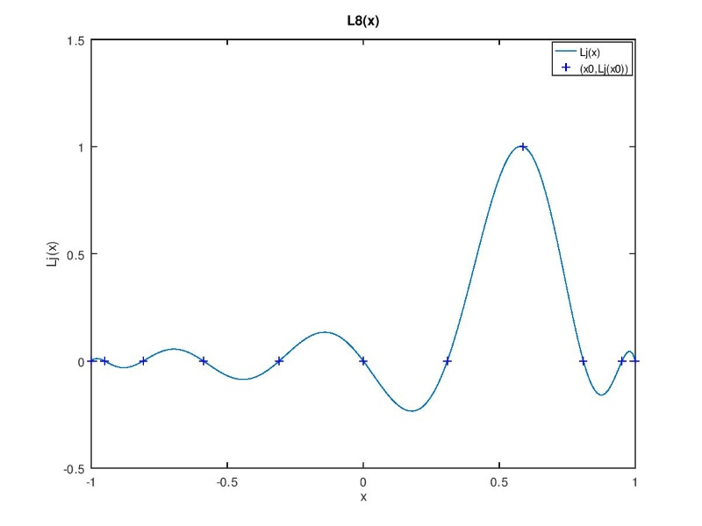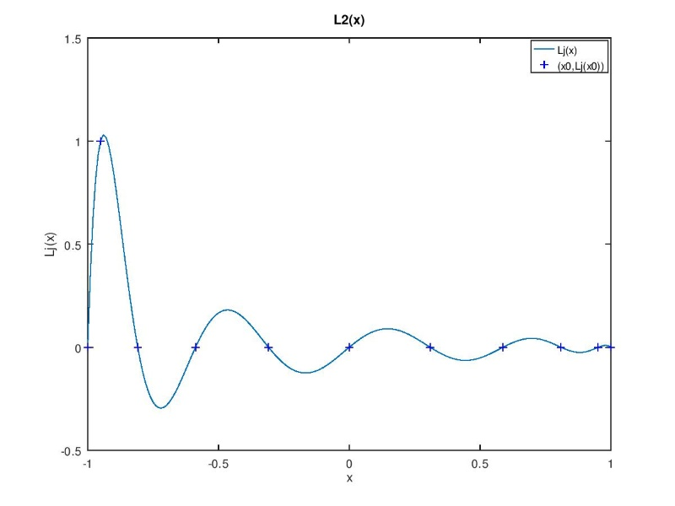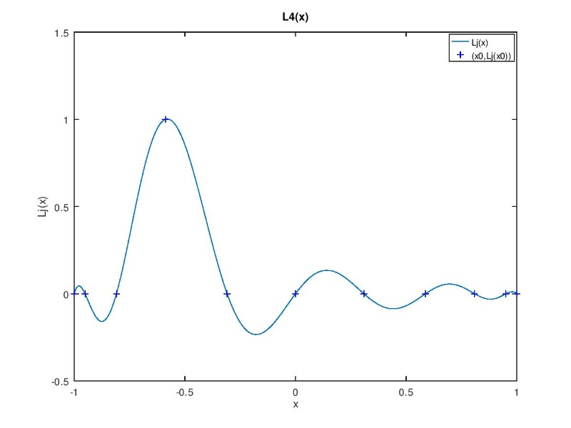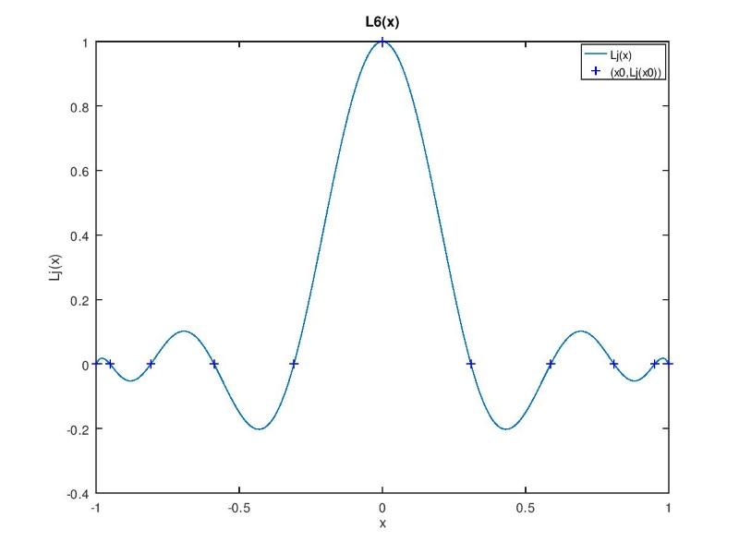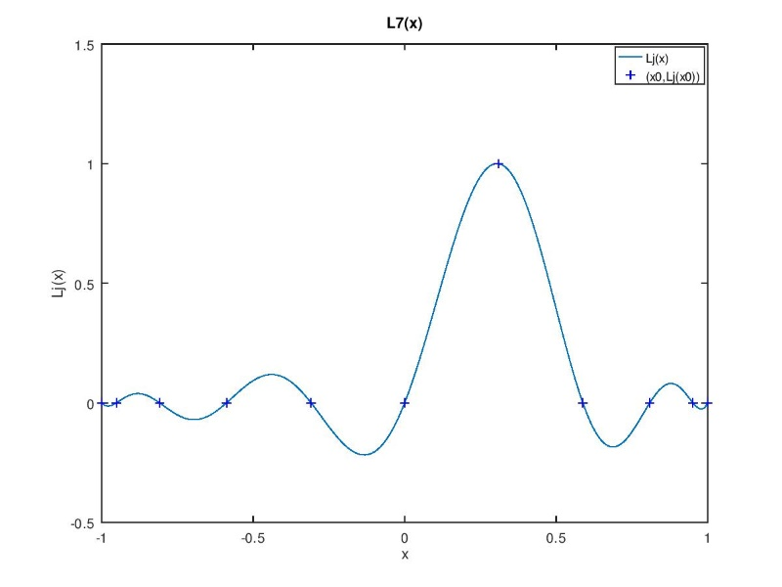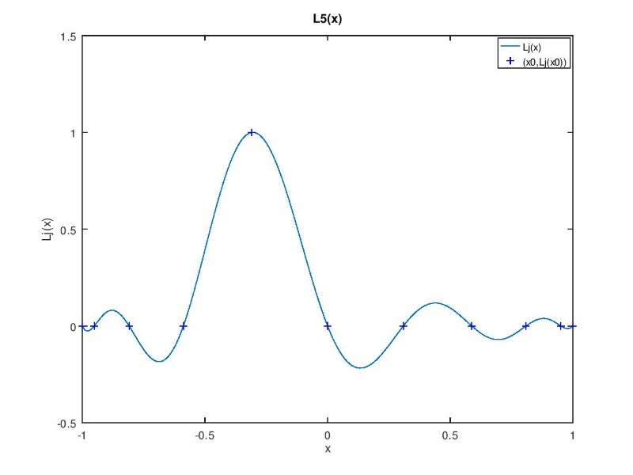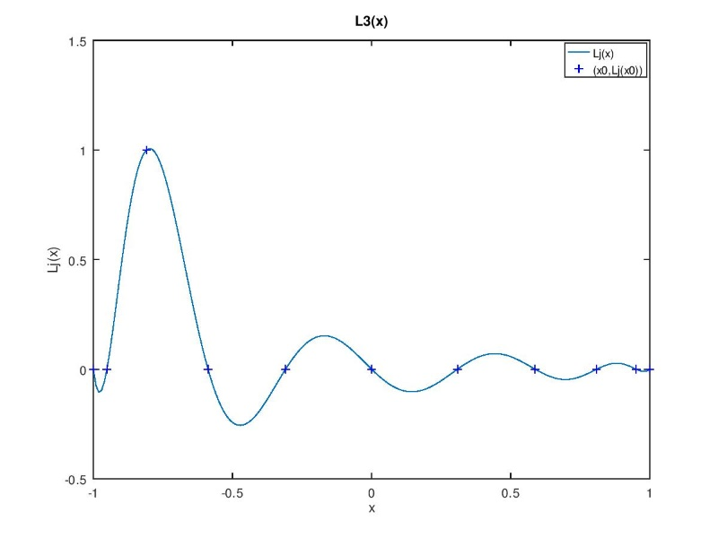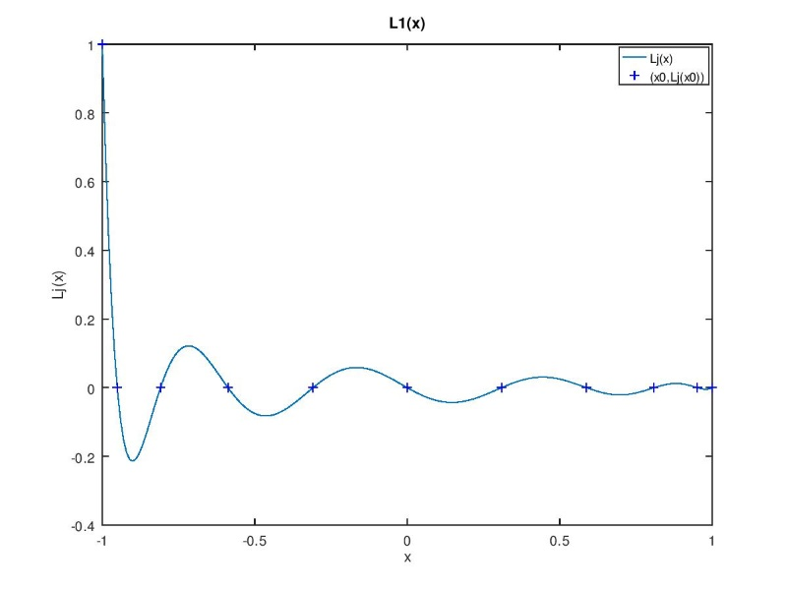

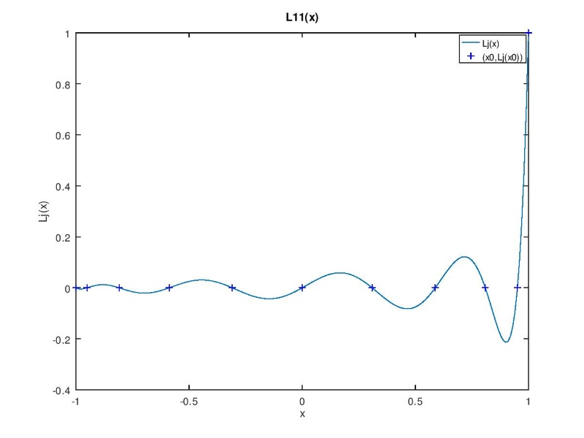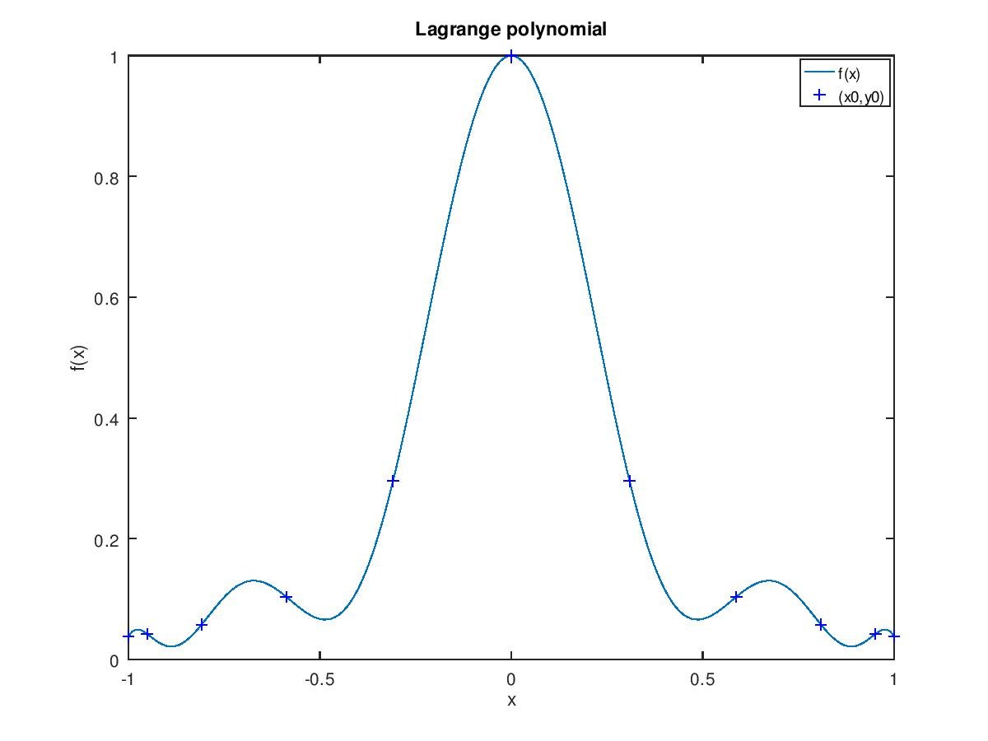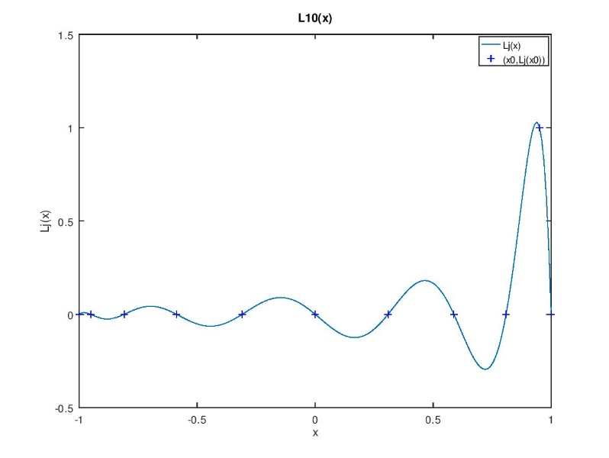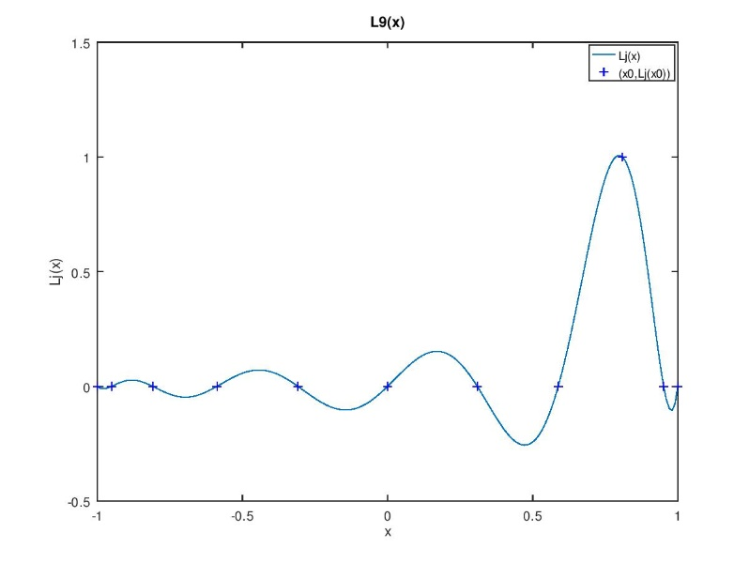

HW1_D

clear all

clc

xi=[-1.0000,-0.9511,-0.8090,-0.5878,-0.3090,0.0000,0.3090,0.5878,0.8090,0.9511,1.0000];

yi=[0.0385,0.0424,0.0576,0.1038,0.2952,1.0000,0.2952,0.1038,0.0576,0.0424,0.0385];

n=size(xi',1);

A=zeros(n,n);

R=zeros(n,1); #A*sov=R

for i=1:n

if (i==1 | i==n)

A(i,i)=1;

R(i)=0;

continue

endif

A(i,i-1)=(xi(i)-xi(i-1))/6;

A(i,i)=(xi(i+1)-xi(i-1))/3;

A(i,i+1)=(xi(i+1)-xi(i))/6;

R(i)=(yi(i+1)-yi(i))/(xi(i+1)-xi(i))-(yi(i)-yi(i-1))/(xi(i)-xi(i-1));

endfor

sov=A\R #second order value

figure(1)

x=[];

y=[];

for i=1:n-1

x_now=xi(i):0.01:xi(i+1);

di=xi(i+1)-xi(i);

y_now=sov(i)/6 *((xi(i+1)-x_now).^3/di-di*(xi(i+1)-x_now))...

+ sov(i+1)/6 *((x_now-xi(i)).^3/di-di*(x_now-xi(i)))...

+ yi(i)*(xi(i+1)-x_now)/di + yi(i+1)*(x_now-xi(i))/di;

x=[x,x_now];

y=[y,y_now];

endfor

plot(x,y,xi,yi,"b+")

xlabel("x");

ylabel("f(x)");

legend("f(x)","(x0,y0)");

title("cubic spline");

print("-djpg","D_cubic spline");

